For: The Canadian Entomologist

Overwintering survival of bagworms, Thyridopteryx ephemeraeformis Haworth (Lepidoptera: Psychidae): influence of temperature and egg cluster weight

Marc Rhainds ^{1*}, Jacques Régnière ², Heather J. Lynch ³ and William Fagan ⁴

¹ Natural Resources Canada, Canadian Forest Service - Atlantic Forestry Centre, P.O. Box 4000
Fredericton, New Brunswick, Canada, E3B 5P7
² Natural Resources Canada, Canadian Forest Service – Laurentian Forestry Centre, 1055 du P.E.P.S. Street, P.O. Box 10380, Québec, Québec, G1V 4C7
³ Department of Ecology and Evolution, State University of New York at Stony Brook
⁴ Department of Biology, University of Maryland, College Park, MD 20742
* Corresponding Author: mrhainds@RNCan-NRCan.gc.ca

Abstact
The present study relates the survival rate of bagworm eggs to extreme winter temperature and weight of egg clutches. The eggs were collected in the spring of 2009 at 104 locations in the mid-western United States across a latitudinal range from 36.5 to 41.5ºN. Egg survival after a 1-wk incubation period was over-dispersed, which indicated that survival of individual eggs within a clutch is non-random, eggs tending to either all survive or all die. Logistic regression analysis revealed that the survival of eggs, assessed after 1 or 12 wks of incubation significantly increases with the weight of egg clutches and extreme winter temperature (expressed as the maximum temperature during the coldest day of winter). Lethal temperature for 50% of egg clusters was -14°C for clusters weighing 0.1g, and -18.1°C for 0.4g clusters. The regression model developed herein constitutes a tool to forecast the persistence of bagworm populations in recently colonized locations in Michigan and Southern Ontario.

Résumé
La présente étude relie le taux de survie des œufs de la chenille burcicole aux températures extrêmes et au poids des masses d’œufs. Les œufs ont été récoltés au printemps 2009 dans 104 localités du centre-ouest des États Unis, le long d’un gradient latitudinal allant de 35.5 à 41.5°N. La survie des œufs après une semaine d’incubation était sur-dispersée, ce qui a indiqué que la survie des œufs individuels au sein d’une même masse est non-aléatoire, ces œufs tendant à tous survivre ou tous mourir à l’unisson. L’analyse par régression logistique a révélé que la survie des oeufs, évaluée après 1 ou 12 semaines d’incubation, augmente significativement avec le poids de la masse d’œufs dans laquelle ils se trouvent, et ce en fonction de la température maximum du jour le plus froid auquel ils ont été exposés pendant l’hiver. La température létale pour 50% des masses d’œufs est de -14°C pour les masses pesant 0.1g, alors qu’elle est de -18.1°C pour les masses de 0.4g. Le modèle de régression développé ici constitue un outil pour prédire la persistance des populations de chenille burcicole dans les endroits récemment colonisés du Michigan et du sud de l’Ontario.

Introduction
Insects have evolved a broad range of adaptations to circumvent the negative impact of extreme seasonal variation in temperature (Tauber et al. 1986). Diapause, defined as a period of suspended activity and development, is a common physiological adaptation to adverse conditions, in particular cold weather during the winter (Leather et al. 1993). Overwintering diapause in the egg stage is prevalent in Lepidoptera with flightless females (Barbosa et al. 1989), including the bagworm Thyridopteryx ephemeraeformis Haworth (Lepidoptera: Psychidae) (Neal et al. 1987). In the fall, flightless female bagworms lay their eggs within their pupal case inside a bag they constructed as larva, and the eggs undergo an obligatory overwintering diapause. The bag, which is made of silk and plant material, moderates fluctuation of temperature and enhances the survival of eggs during winter (Rivers et al. 2002; see also Barbosa et al. 1983). Under laboratory conditions, eggs enclosed in their bag and exposed to -10ºC for up to 4 days suffer minimal (< 5%) mortality, whereas >75% of eggs die after being exposed for 24 hours to -17ºC (Rivers et al. 2002). These results suggest that (1) the maximum temperature during the coldest day of winter (24 hour period) may be used to predict the survival of eggs in the field; and (2) the threshold associated with significant egg mortality ranges between -10 to -17ºC.
In some insect species, the number of eggs laid by a female in a cluster influences survival e.g., large clutches buffer against cold temperature and desiccation for diapausing eggs (Stamp 1980, Danks 2002). Mated female bagworms lay a variable number of eggs in their pupal case (from < 100 to > 1700; Rhainds et al. 2008), which may affect overwintering survival. In the present study, we analysed the effects of cold temperature exposure and cluster weight on survival of bagworm eggs under natural conditions.

Methods
Between 5 and 35 bags containing egg masses were collected at the end of the winter in March – April 2009 on juniper or arborvitae at 104 locations in the mid-western United States (Figure 1 in Rhainds and Fagan 2010). The pupal cases containing eggs were removed from their bag, weighed to the nearest 0.01 g, placed individually in Solo cups (N = 1359), and kept at room temperature in the laboratory. After 7 days, a subsample including two clutches for most locations (N = 190) was randomly selected. These egg clutches were cut open and a subsample of 50 eggs was classified as either live or dead based on their colour, as white eggs are alive and black eggs are dead (Sadof and Rhainds 2009). The remaining egg clusters were monitored daily over 12 weeks to determine hatching of early instars. At the end of that period, larvae had ceased to emerge and the unhatched clutches (N = 61) were dissected; all of them contained only shrunken, dead black eggs.
The maximum temperature during the coldest day of winter (15 or 16 January 2009) was estimated at the 104 sampling locations by interpolation using inverse-squared-distance weighting of the data from 39 nearby meteorological stations.
The relationship between survival of eggs after 7 days of incubation (s), temperature (T) and egg clutch weight (w) was determined by logistic regression using the model:
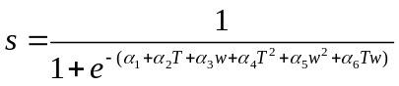
where 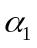 to 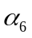 are parameters associated with each effect, its square or their interaction.
Observations of egg clutch hatch after 12 weeks provided binary values (1: some hatch, 0: no hatch). The probability of hatch at the clutch level was also related to temperature and clutch weight by a logistic model analogous to equation .
Data analysis was conducted with PROC LOGISTIC of SAS/9.2. Full models (equation ) were reduced, one term at a time, until all remaining terms were significantly different from zero (). With the 1-week incubation experiment, because samples of 50 eggs were tested in each temperature/cluster weight combination, it was possible to test directly and correct for over-dispersion. To test for over-dispersion among the 12-wk cluster hatch data, which were not replicated at specific temperature and weight combinations, equation was first fitted after grouping the data into 1°C temperature classes and 0.1 g weight classes. Once it was established that these data were not over-dispersed, the model was fitted to data from individual clusters.

Results
The deviance goodness of fit test for 1-wk egg survival data fitted to equation was highly significant (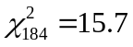, P<0.0001). To obtain final parameter estimates and significance tests, the covariance matrix was multiplied by the deviance. The final (reduced) model had three highly significant terms (P<0.0001):
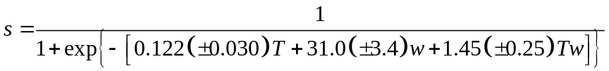
This model had 90.9% concordance, likelihood ratio=463 (P<0.0001) and adjusted 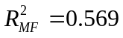(Menard 2000). The over-dispersion of survival rates is clearly visible in Fig. 1, where most observations align near either 0 or 100% survival where the model predicts low survival. This over-dispersion pattern suggests non-independence of egg survival within clutches, so that eggs in a given clutch tend to have similar fates (either survive or die).
There was no evidence of over-dispersion in the 12-week incubation cluster survival data (Deviance 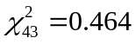, P=0.999). Equation fitted those data very well, with three highly significant terms (P < 0.005) in the reduced model:
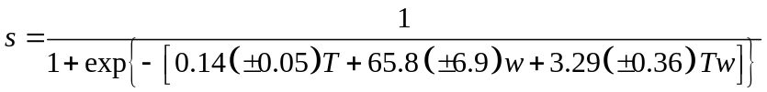
This model had 98.3% concordance, likelihood ratio=1450 (P<0.0001), AIC=176.96 and adjusted 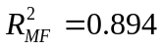 (Fig. 2). It should be noted that for both measures of survival (1- or 12-week incubation period), a portion of the range of independent variables (w > 0.4g and T < -15°C) was not represented in our data, and that the survival response surface in that region is based on the extrapolation of the response surface (shaded area in Figs. 1, 2).

Discussion
Our data indicate that the overwintering survival of bagworm eggs inside clusters is non-independent, and that most eggs within a cluster tend to have the same fate (to either survive or die), a phenomenon that had been previously suggested from field observations (Balduf 1937). This survival is affected very strongly by the weight of the cluster, and by the extreme temperature to which the cluster is exposed in winter (expressed here as the maximum temperature on the coldest day of winter). The eggs of T. ephemeraeformis are not freeze tolerant and have low levels of cryoprotectants; resistance to cold weather is due to the physical protection provided by the maternal bag (Rivers et al. 2002). The physical or physiological mechanisms underlying the enhanced survival in large egg clutches remain to be investigated.
The survival of eggs in the field is dependent upon the maximum temperature during the coldest day of winter (Figs. 1, 2; see also Rivers et al. 2002), and this temperature is highly dependent on latitude in the mid-western United States (Fig. 3a). Elevation, in contrast, played a minor role in our dataset as it ranged only from 100 to 300 m. There was also a strong negative correlation between latitude and egg cluster weight (-0.03g/°N, Fig. 3b). These sources of geographical variation in egg survival are undoubtedly important determinants of the insect’s potential range in North America. The cluster survival function (equation ) can be rearranged to estimate the temperature T_{c} and weight w_{c} at which specific critical survival rates s_{c} can be expected to occur (Fig. 4):
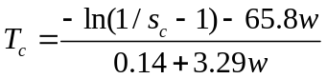

Ongoing trends of global warming in the northern hemisphere influence the geographic range distribution of herbivorous insects in large part due to an increase of temperature in the winter (Bale et al. 2002). The relationships expressed in equation can be used to predict the persistence of bagworm populations that invade novel areas, as recently documented in Michigan (Russell 2011) and southern Ontario (MR, personal observations). Expansion of the geographic range of bagworms in the area of Windsor, Ontario, near the border with Detroit, Michigan, is of particular concern due to relatively mild winter conditions combined with heavy commercial traffic resulting in human-assisted spread of ballooning larvae. Contingency plans to manage bagworm populations along major highways near Windsor need to be implemented, in particular by taking into account abundance data, population distribution, weather records, and size (weight) of egg clusters.

Acknowledgements
We thank C. Quesada and C. Sadof for logistic support.

References
Balduf, W.V. 1937. Bionomic notes on the common bagworm, Thyridopteryx ephemeraeformis
Haw., (Lepid., Psychidae) and its insect enemies (Hym, Lepid.). Proceedings of the Entomological Society of Washington, 39: 169-184.
Bale, J.S., Masters, G..J., Hodkinson, I.D., Awmack, C., Bezemer, T.M., et al. 2002. Herbivory
in global climate change research: direct effects of rising temperatures on insect herbivores. Global Change Biology, 8: 1-16.
Barbosa, P., Krischnik, V., and Lance, D. 1980. Life-history traits of forest-inhabiting flightless
Lepidoptera. American Midland Naturalist, 122: 262-274.
Barbosa, P., Waldvogel, M.G., and Breisch, N.L. 1983. Temperature modification by bags of the
bagworm Thyridopteryx ephemeraeformis (Lepidoptera: Psychidae). Canadian Entomologist, 115: 855-888.
Danks H.V. 2002. Modification of adverse conditions by insects. Oikos, 99: 10-24.
Leather, S.R., Walters, K.F.A., and Bale, J.S. 1993. The ecology of insect overwintering.
Cambridge University Press, New York, NY.
Menard, S. 2000. Coefficients of determination for multiple logistic regression analysis. American Statistician 54: 17-24.
Neal, J.W., Raupp, M.J., and Douglass, L.W. 1987. Temperature-dependent model predicting
larval emergence of the bagworm, Thyridopteryx ephemeraeformis (Haworth) (Lepidoptera: Psychidae). Environmental Entomology, 16: 1141-1144.
Rhainds, M., Leather, S.R., and Sadof, C. 2008. Polyphagy, flightlessness, and reporoductive
output of females: a case study with bagworms (Lepidoptera: Psychidae). Ecological Entomology, 33: 663-672.
Rhainds, M., and Fagan, W.F. 2010. Broad-scale latitudinal variation in female reproductive
success contributes to the maintenance of a geographic range boundary in bagworms (Lepidoptera: Psychidae). PLOS ONE, 5: e14166.
Rivers, D.B., Antonelli, A.L., and Yoder, J.A. 2002. Bags of the bagworm Thyridopteryx
ephemeraeformis (Lepidoptera: Psychidae) protect diapausing eggs from water loss and chilling injury. Annals of the Entomological Society of America, 95: 481-486.
Russell, H. 2011. Bagworms extend their reach northward. Michigan State University Extension
Bulletin, Turf and Landscape Archive, July 2011.
Sadof, C., and Rhainds, M. 2009. Did the bagworms survive the winter of 2008-2009. Purdue
Extension HN-22-W (http://extension.entm.purdue.edu/publications/HN-22.pdf).
Stamp, N.E. 1980. Egg deposition patterns in butterflies: why do some species cluster their eggs
rather than deposit them singly? American Naturalist, 115: 367-380.
Tauber, M.J., Tauber, C.A., and Masaki, S. 1986. Seasonal adaptations of insects. Oxford
University Press, New York, NY.

Figure Captions

Figure 1. Proportion of live (white) eggs among subsamples of 50 eggs from egg masses after 7 days (●: above the response surface; ●: beneath the surface). Shaded area: area of extrapolation.

Figure 2. Proportion of eggs clusters from which some hatch was observed after 12 wks incubation. Data summarized into 1°C and 0.1g classes for graphical presentation (but not for model fitting). Surface is equation ; ●: groups with only one or two clusters. Shaded area: area of extrapolation.

Figure 3. Relationship between (a) maximum temperature on the coldest day of winter (2009), or (b) mean cluster egg weight (±SEM), and latitude.

Figure 4. Lethal temperature corresponding to 10, 50 and 90% survival of bagworm egg clusters of increasing weight (equation ). Grey area: zone of extrapolation where no data were available.
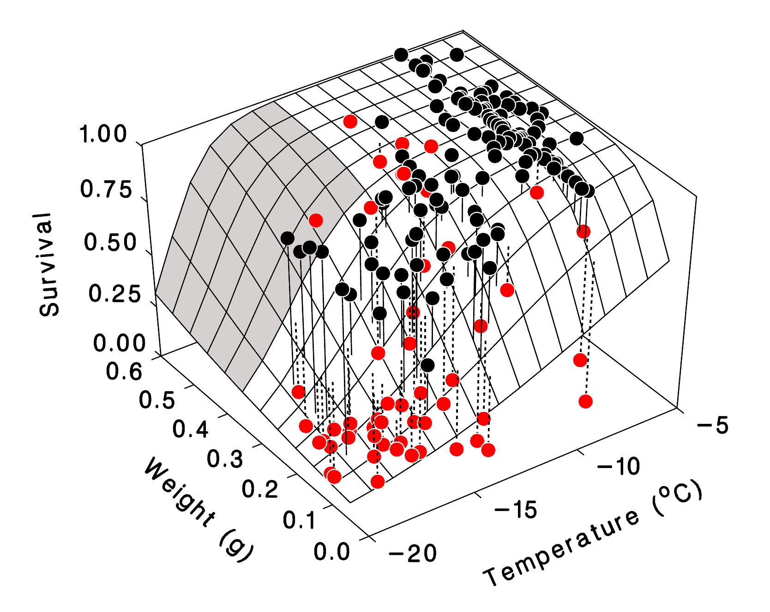
Figure 1
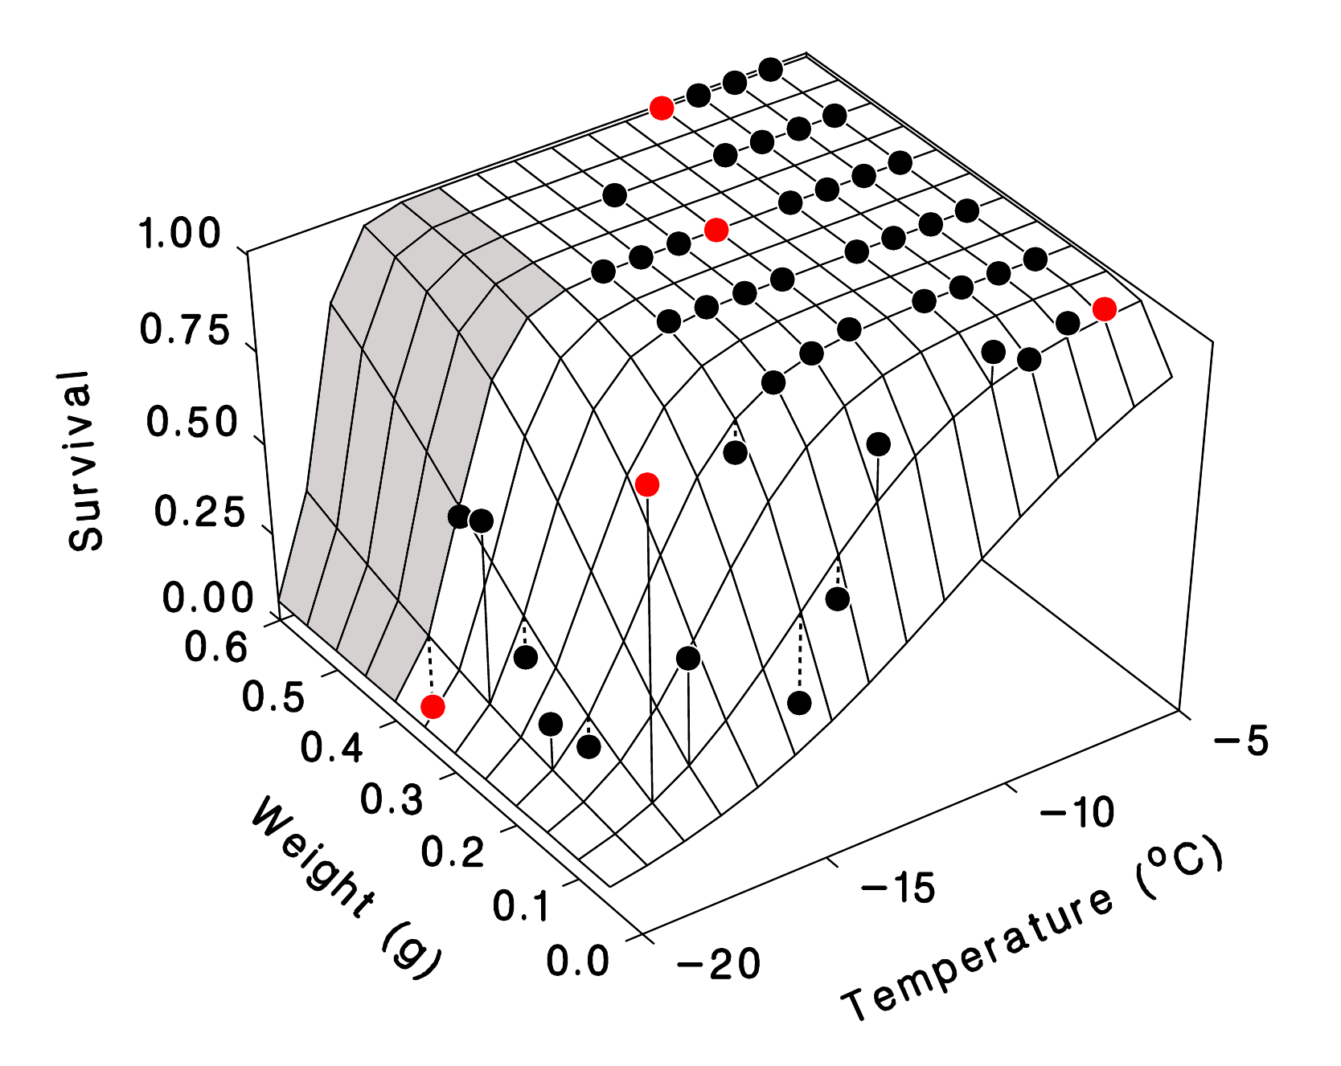
Figure 2
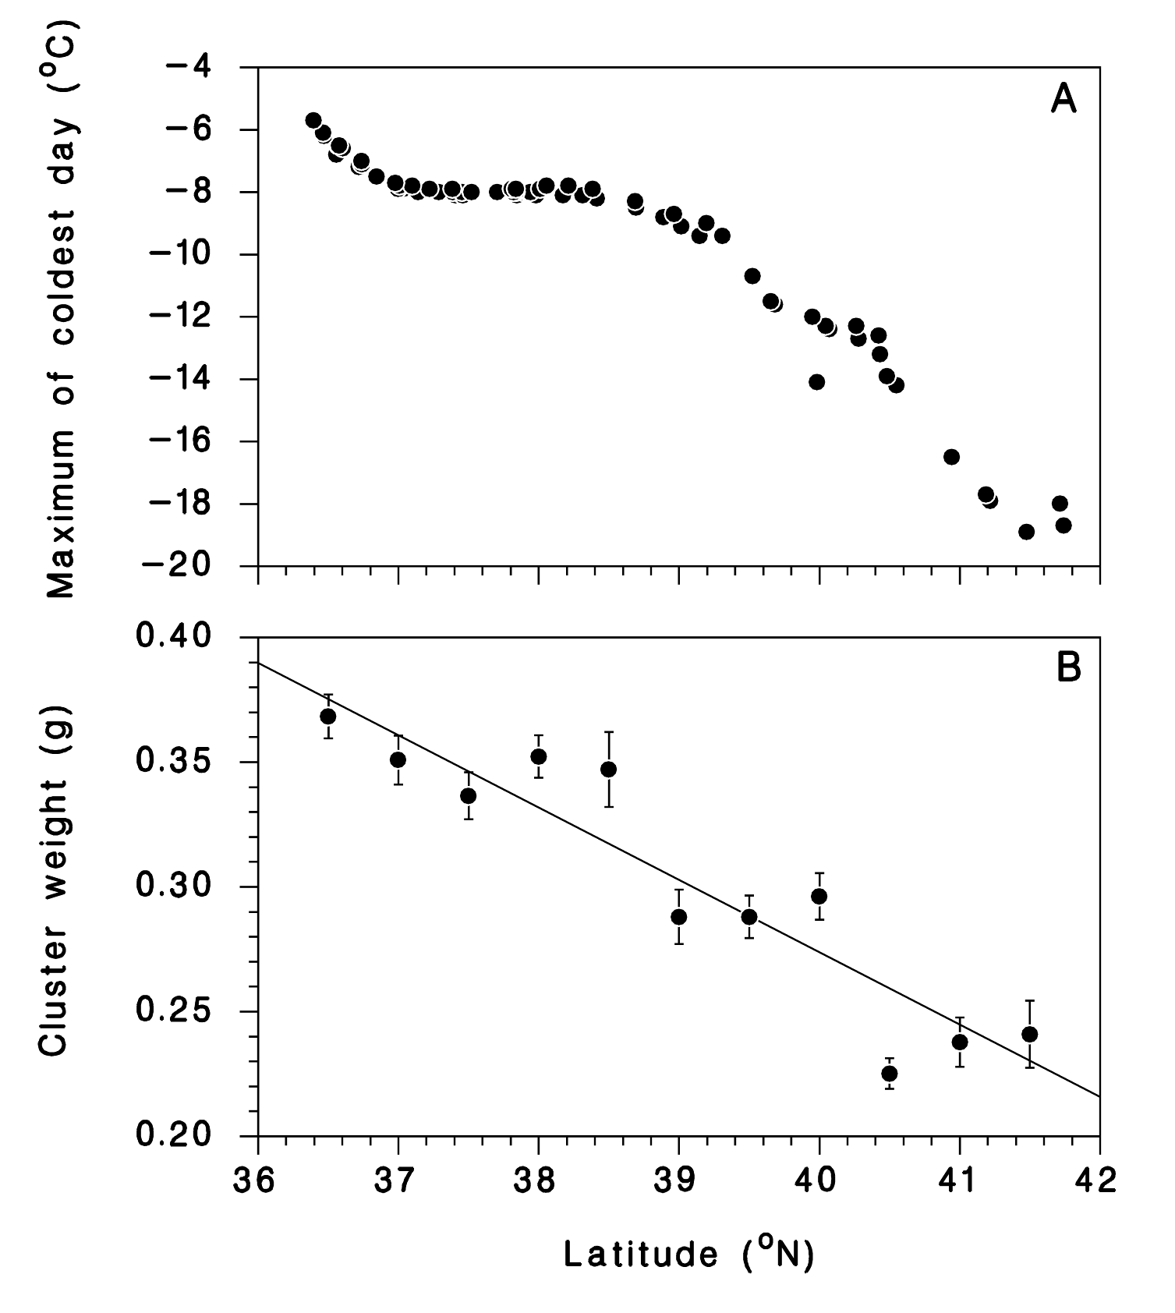
Figure 3

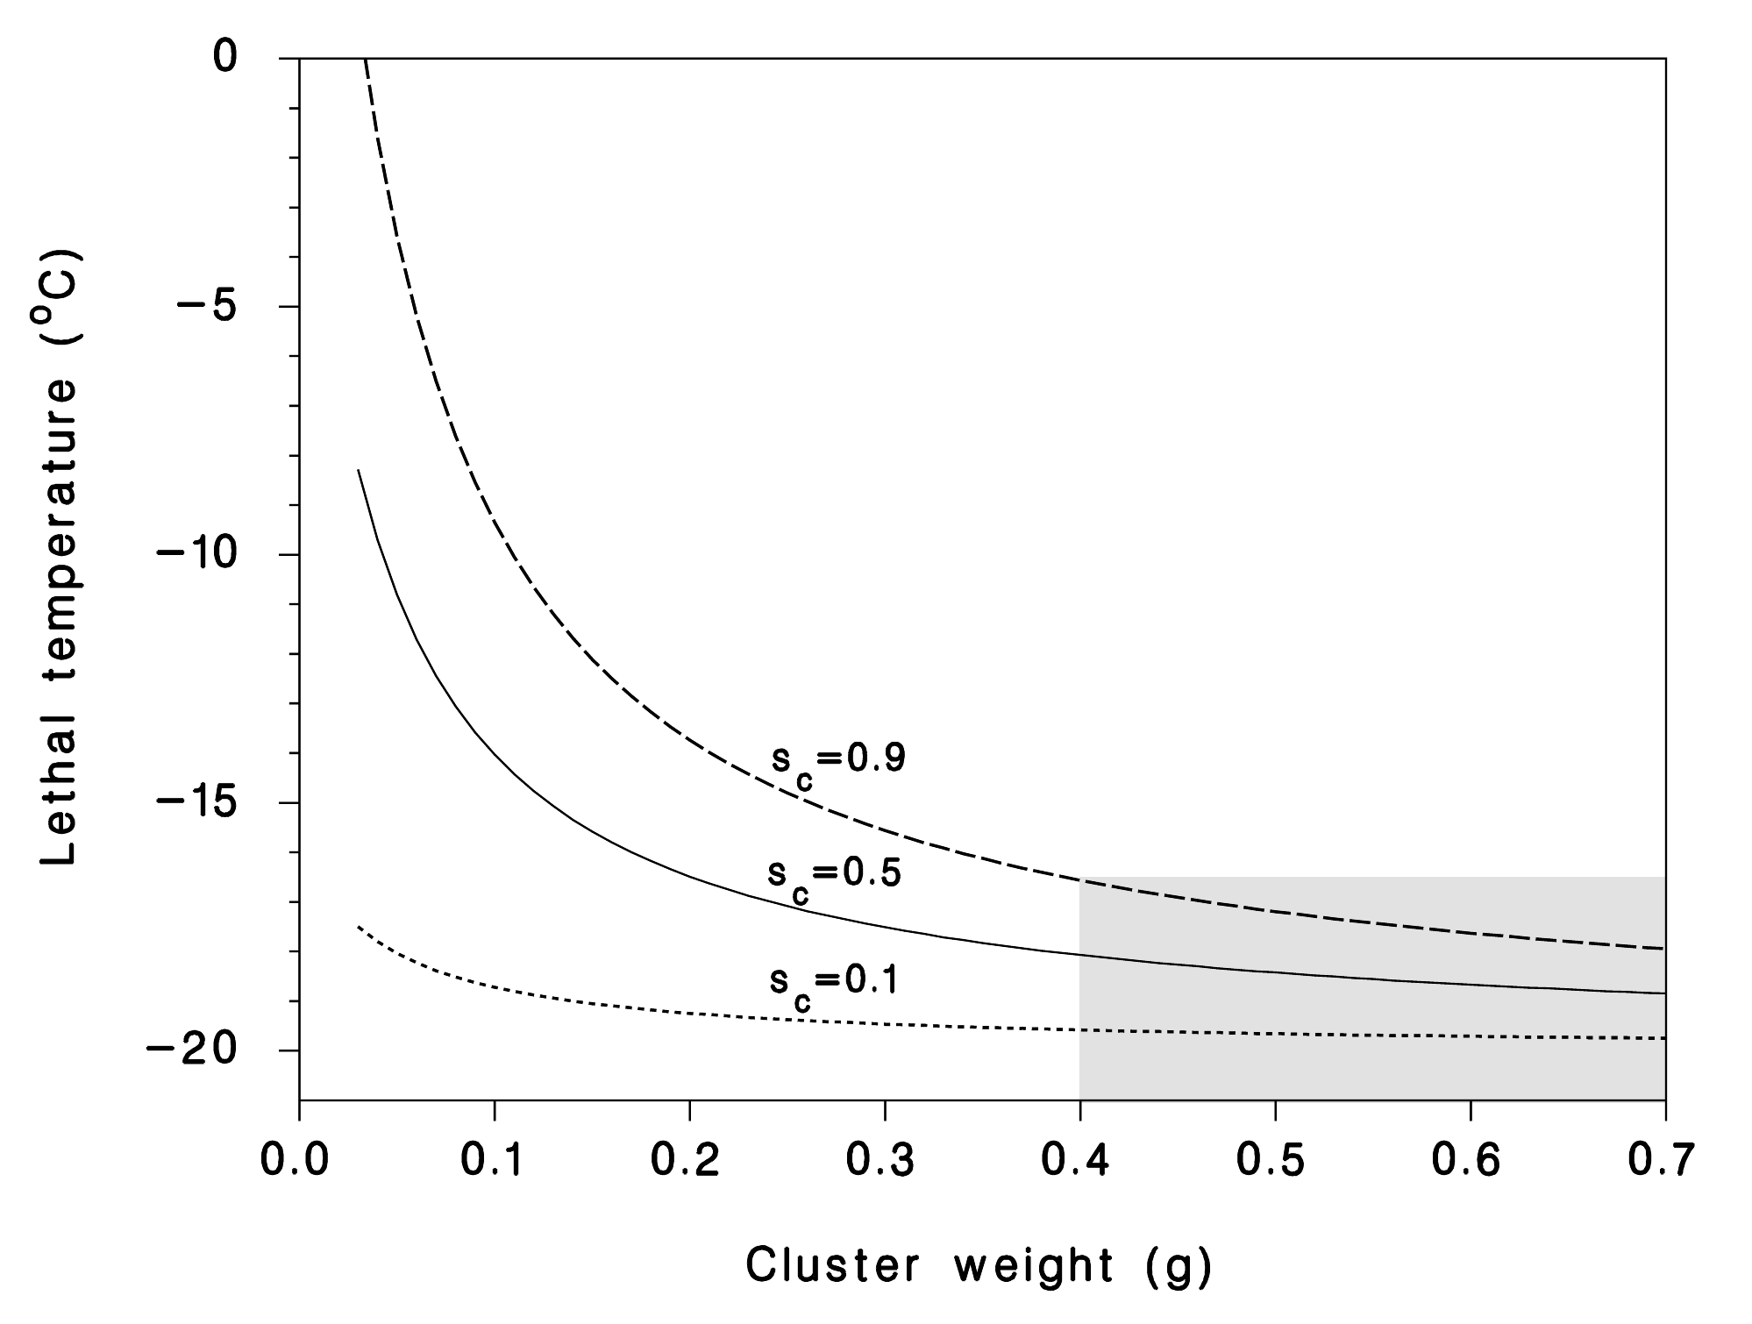
Figure 4

